COMPUTER ORGANIZATION AND ASSEMBLY LANGUAGE

TOPIC:
INCREMENT AND DECREMENT

NAME:
MUHAMMAD TALHA
SECTION:
4/A
ROLL#:
241890

INSTRUCTOR:
MS ROMANA MAROOF

LAB TASK5.1
LED Control Simulation Using INC, DEC, and JMP
RESULTS:
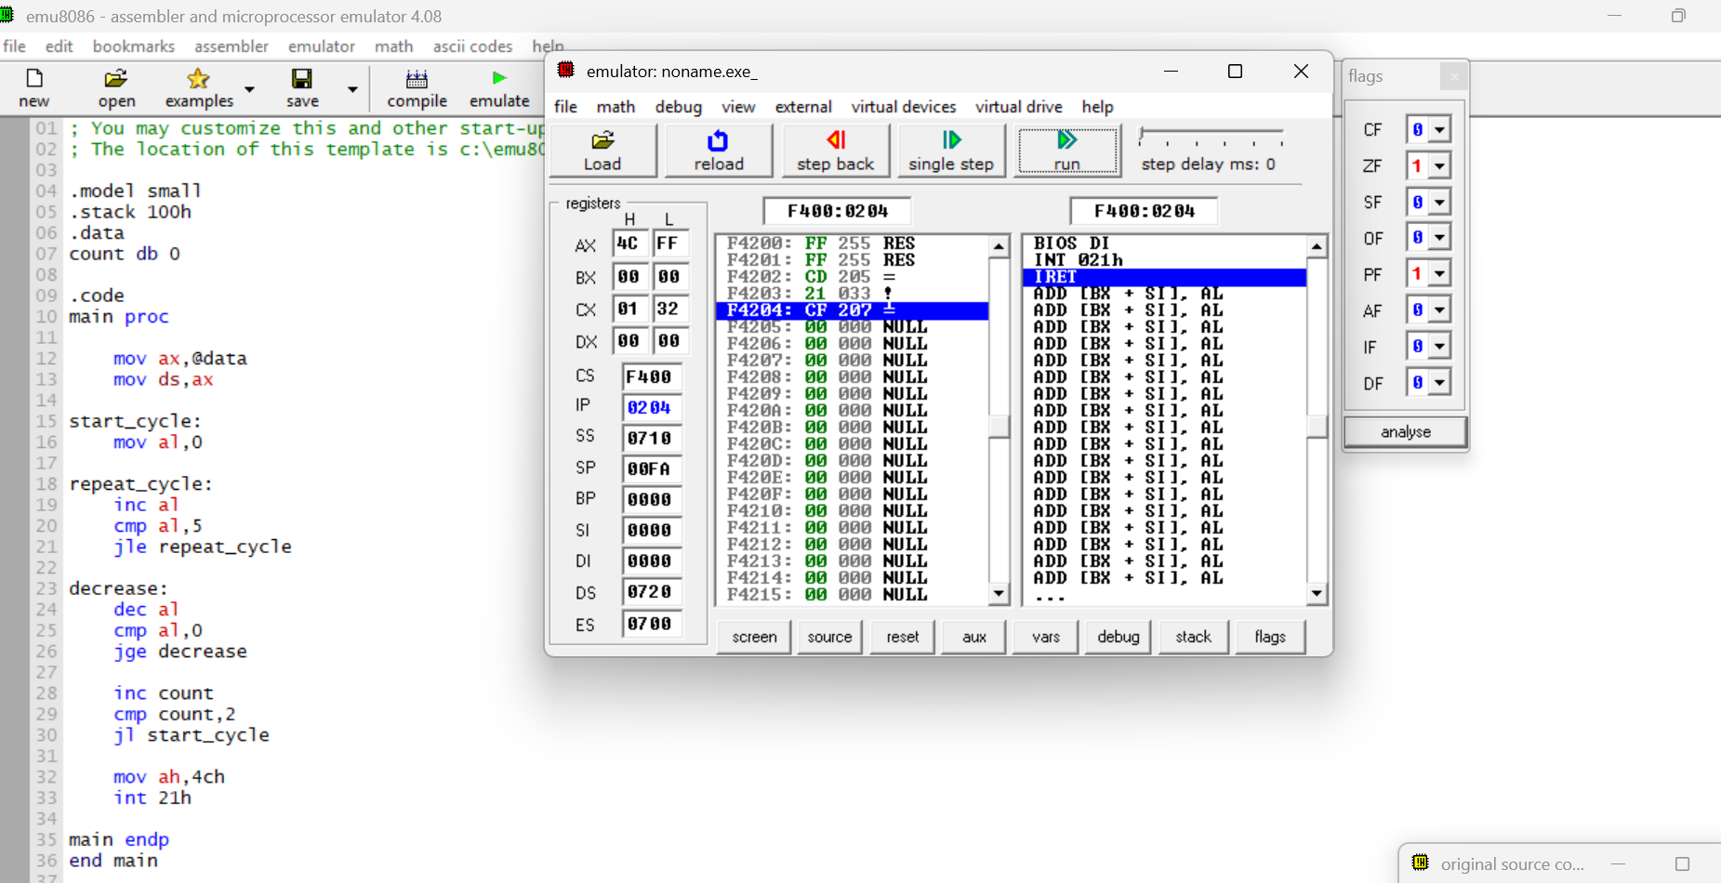
STEPS:
- start_cycle: label to begin one brightness cycle.
- mov al,0: sets brightness to 0 at start of cycle.
- repeat_cycle: label for increasing brightness.
- inc al: increases brightness by 1.
- cmp al,5 : compares brightness with 5.
- jle repeat_cycle: keeps increasing while value is less than or equal to 5.
- decrease: label for decreasing brightness.
- dec al : decreases brightness by 1.
- cmp al,0 : compares brightness with 0.
- jge decrease : keeps decreasing while value is greater than or equal to 0.
- inc count : increases cycle counter after one full up-down cycle.
- cmp count,2 : checks if two cycles are completed.
- jl start_cycle : if less than 2 cycles, start again.
- mov ah,4ch : prepares DOS terminate program function.
- int 21h : exits the program properly.

LAB TASK 5.2
Temperature Sensor Data Inversion (NOT, NEG, and Unconditional JMP)
RESULTS:
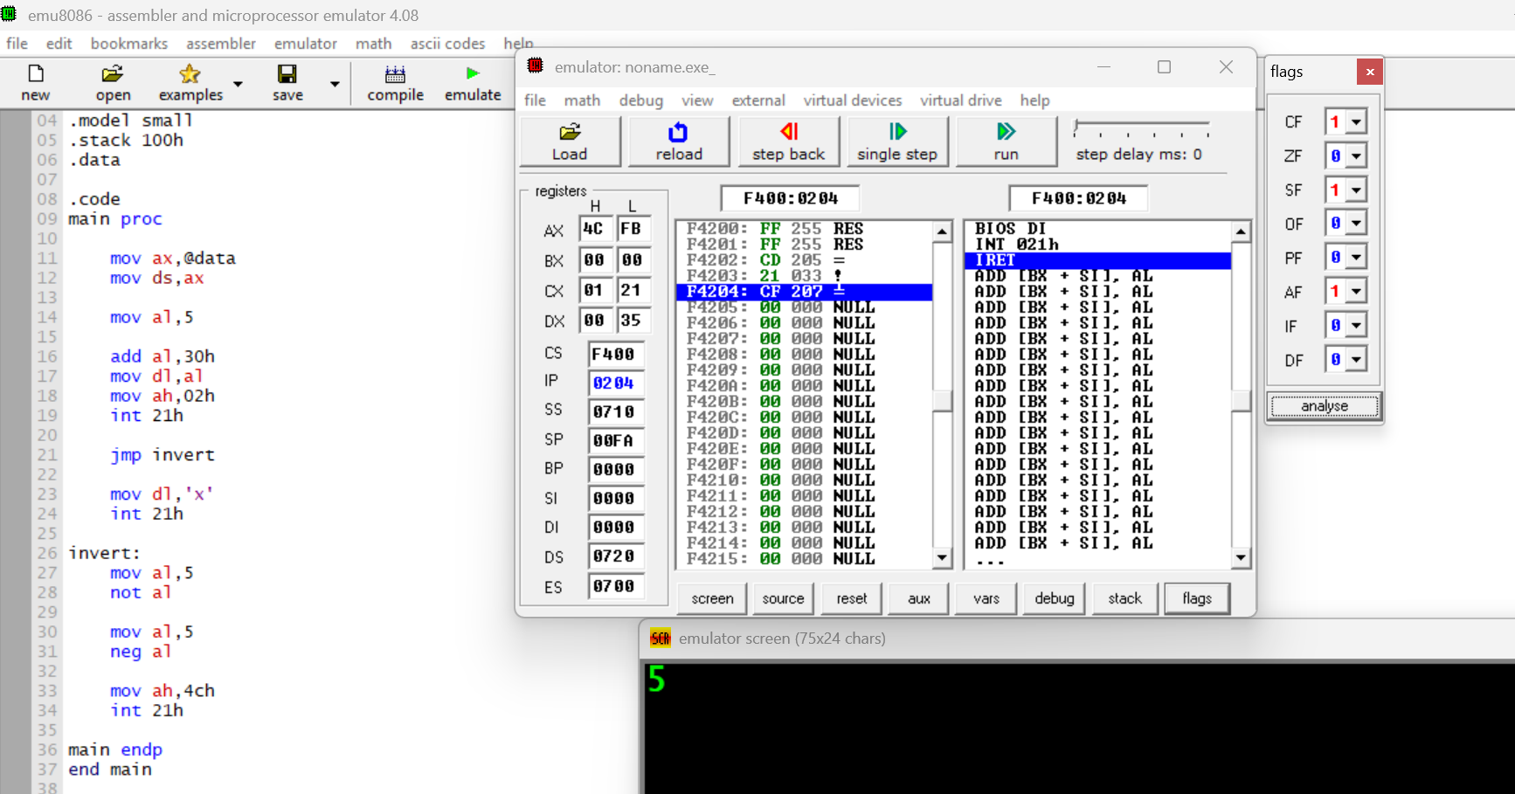
STEPS:
- mov al,5 loads original sensor data (5).
- add al,30h : converts number to ASCII for display.
- mov dl,al : moves value to DL for printing.
- mov ah,02h : selects print character function.
- int 21h : displays original sensor value.
- jmp invert : skips unnecessary instruction below.
- mov dl,'x' : skipped instruction (not executed).
- invert: label for inversion process.
- mov al,5 : reload original sensor value.
- not al : inverts all bits (bitwise inversion).
- mov al,5 : reload original value again.
- neg al : converts value to two’s complement (signed correction).
- mov ah,4ch : prepares program termination.
- int 21h : exits program properly.

LAB TASK 5.3
unconditional JUMP
RESULTS:
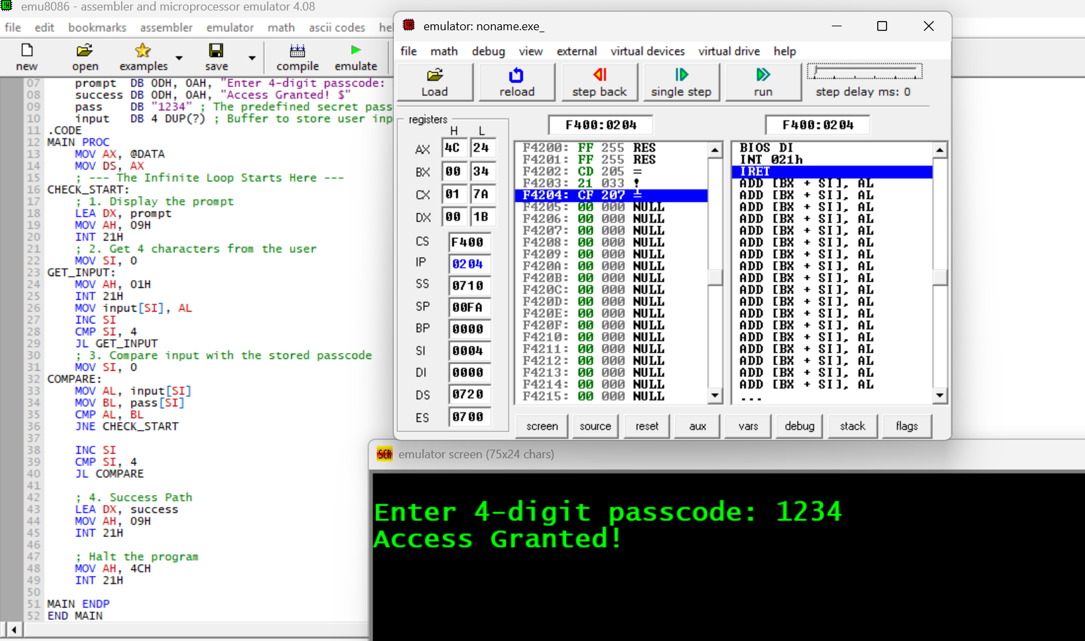
STEPS:
- MODEL SMALL / .STACK 100H : setup program memory
- prompt DB … / success DB … / pass DB "1234" / input DB 4 DUP(?) : store messages, correct passcode, and input buffer
- MOV AX,@DATA / MOV DS,AX : initialize data segment
- CHECK_START: : label to restart if passcode wrong
- LEA DX,prompt / MOV AH,09H / INT 21H : display passcode prompt
- GET_INPUT: : read 4 characters into input buffer
- CMP AL,pass[SI] / JNE CHECK_START : compare each digit; retry if wrong
- LEA DX,success / MOV AH,09H / INT 21H : display success message
- MOV AH,4CH / INT 21H : terminate program

